**Wednesday May 8th, 2019**

13:33 — Here I am. Let’s get to it.

13:45 — I just finished writing and debugging some basic code using state in React. Here’s a sample of my code along with what it actually output:

class App extends React.Component {

constructor() {

super()

this.state = {

name: "Cameron",

age: 22

}

}

render () {

return (

<div>

<h1>{this.state.name}</h1>

<h3>{this.state.age} years old</h3>

</div>

)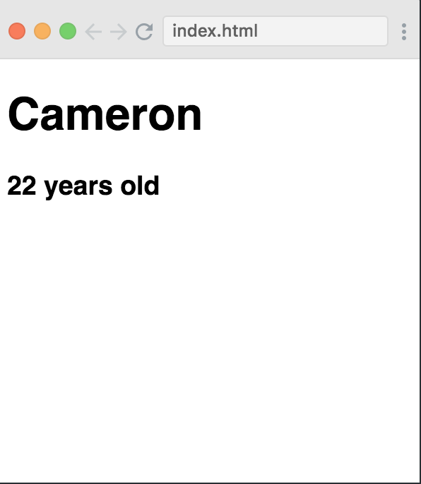

}

}

13:49 — Bob solved the problem in basically the same fashion I did. Now, I’m going to move on to the second state practice video.

13:57 — I just finished the practice video. I wrote some code that will render different messages based on whether the user is logged in or logged out. It’s pretty cool. Check out the code and output here! (Edit: not sure why this 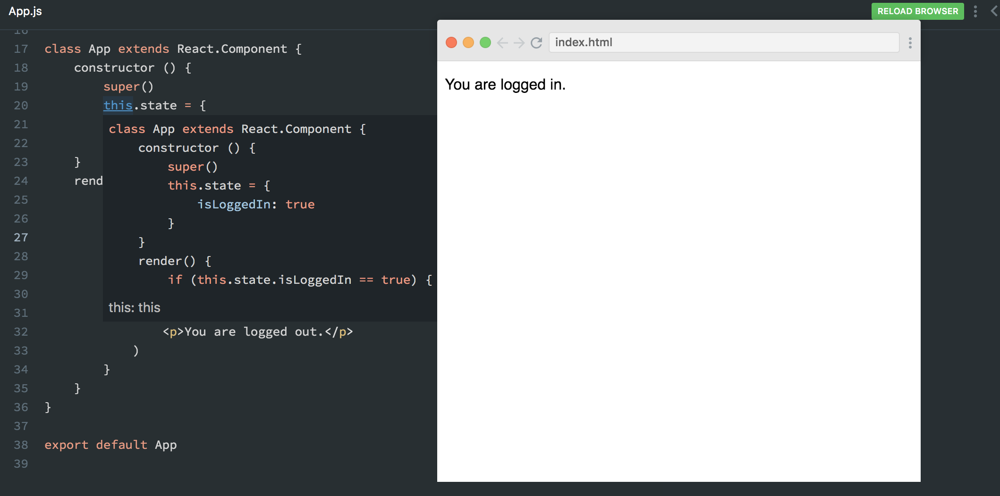screenshot turned out kinda funky… Oh well)

13:58 — Now I’ve got some other business to attend to. I’ll be back shortly for another 15-20 minute pomodoro session.

14:49 — I’ve just got about 10 minutes. Let’s get a quickie in haha.

14:51 — He coded this solution a bit more eloquently. By implementing a variable he was able to handle every situation with just a single return statement instead of having to have multiple possible return statements based on a condition as I had opted to do.

14:53 — Here’s an example of his slightly more eloquent code:

class App extends React.Component {

constructor() {

super()

this.state = {

isLoggedIn: true

}

}

render() {

let wordDisplay

if (this.state.isLoggedIn === true) {

wordDisplay = "in"

} else {

wordDisplay = "out"

}

return (

<div>

<h1>You are currently logged {wordDisplay}</h1>

</div>

)

}

}

14:59 — I’ve gotten a bit done on the next exercise but I have a call I need to take right now. I’ll upload more later:

class App extends React.Component {

constructor() {

super()

const todoList = todosData.map(item => <TodoItem key={item.id} item={item}/>)

}

render () {

return (

)

}

}

17:45 — I’m back. Let’s go for 20-30 minutes before my girl drags me to dinner haha.

17:52 — I’m going through another exercise. I’m going to go review how Bob Ziroll used variables in conjunction with state.

18:00 — The previous exercise was a bit meeeeh to be honest. I’m a bit tired and while I got the basic outline right, I missed out on a couple details.

18:01 — Let’s learn about how events work in React.

18:04 — Event handling is a way of handling events like clicks or hovers so that when our users use our website it is more interactive for them.

18:05 — Event handlers in JavaScript use camel case convention.

18:06 — We use the onClick event handler to do something if a user clicks something on the page.

18:16 — I just got a basic event handler to work for the first time. I feel so tired now lol. Let’s take a break and get back to it tonight or tomorrow morning

**Total time spent coding today: N/A**

**Total time spent coding thus far in May 2019: N/A**

**Total lifetime hours of coding: N/A**